COLLABORATION IN THE VALUATION PROCESS: A REVIEW AND DIRECTION FOR FUTURE RESEARCH

*HASSAN SHUAIBU LIMAN^{a,b}, ABDUL-RASHEED AMIDUª and DEBORAH LEVYª

ª Department of Property, The University of Auckland, Auckland, New Zealand

^{b} Department of Estate Management and Valuation, Federal University of Technology, Minna, Nigeria

Abstract
The commercial property valuation process is highly complex, requiring valuers to use information from different sources, to comply with both internal and external quality control mechanisms, and to exercise professional judgment in dynamic markets and non-routine tasks. Due to the interactive nature of these components of the valuation process, collaboration can be perceived as being central to the quality of estimated values reported by valuers. Yet, little is known in the valuation literature about how valuers collaboratively solve problems and make decisions. This paper reviews literature on valuation decision making and reports that behavioural valuation research is skewed towards examining individual valuer behaviour whereas the behaviour of valuers in a collaborative context has remained largely unexplored. In view of this gap in knowledge, the paper identifies opportunities for future research to explore different dimensions of collaboration in the valuation process. Such research can provide insights that may be used to enhance collaborative practices in property valuation.
Keywords: Property valuation, collaboration, valuer behaviour, valuation process, literature review
*Corresponding Author’s Email: hassan.liman@auckland.ac.nz; elhasliman@yahoo.com

1. Introduction
Reliable property valuations are central to the efficient functioning of the economies of all nations (Wilkinson et al., 2017). This is because of the pivotal roles they play in the operation of both the property and financial markets. Specifically, valuations support individuals and institutional investors by establishing market values of properties for a variety of financial decisions including acquisition, disposal and performance measurements (Baum et al., 2000). The valuation decision-making process, particularly those involving commercial properties, consists of several important components: information is captured by the valuer from different sources (such as through investigation and from the client), valuation firms put robust internal control system to improve the reliability of information handling and technical interpretation, while professional bodies provide governance over the entire valuation process. Due to the interactive nature of all these components, collaboration within the valuation process can be perceived as being central to the quality of the valuation outcomes that are reported to clients and other stakeholders. Yet, little is known in the property literature about how valuers collaboratively solve problems and make decisions. Existing behavioural valuation literature has primarily focused on examining individual valuer behaviour, while the collaborative behaviour of valuers has not been properly scrutinised.
This paper aims to achieve three objectives. Firstly, the paper develops an organising framework for valuation decision making research (Figure 1). Secondly, the paper adopts a native approach to review current knowledge on collaboration in the valuation literature with the intention of identifying areas that require further research. Thirdly, the paper proposes a conceptual framework for analysing collaboration in the valuation process (Figure 3). Future research seeking to examine collaboration in property valuation can adopt the proposed framework to critically examine the different spheres of interaction within the valuation process.
Figure 1: A simple framework of valuation decision making research.
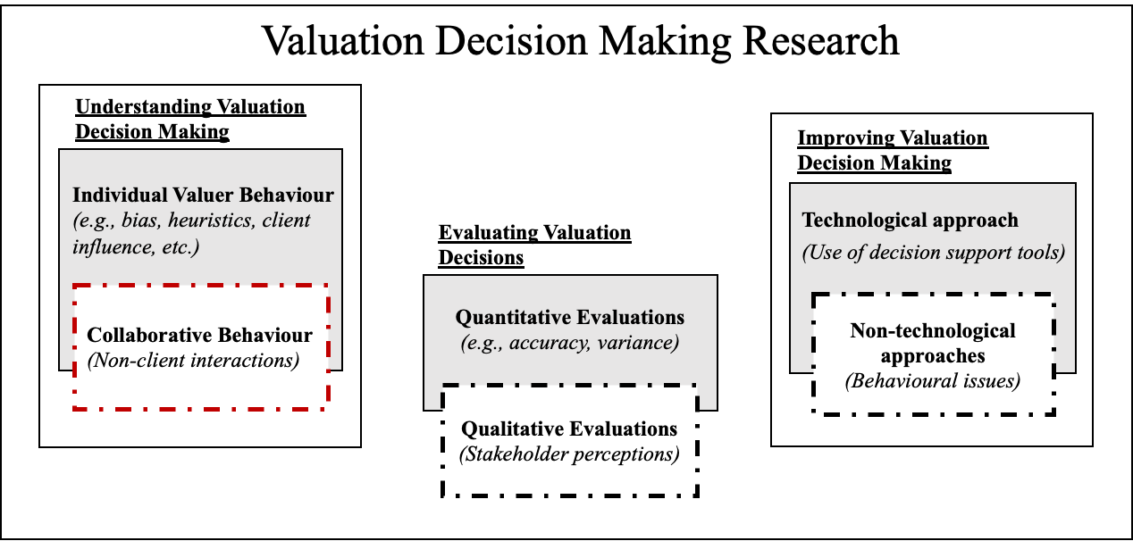
Source: Authors
Following the approach used by Wang and Noe (2010), the framework in Figure 1 shows the three major streams of valuation decision making research (i.e., understanding, evaluating, and improving valuation decision making), the key issues that have been researched within each stream (shaded boxes) and the areas requiring further research (dotted boxes). Motivated by a large body of research that suggest that collaboration has now become a veritable tool for making better decisions especially in complex situations, we argue that one of the areas that require more in-depth investigation in the valuation literature is understanding the role of collaboration in the valuation process. With the exception of studies on valuer-client interactions (i.e., studies on client pressure, feedback and influence on valuation) the behaviour of valuers in a collaborative context has not been critically examined in the literature. In the next section, we review literature on collaboration to contextualise the type of interaction that this review paper is interested in.

2. Literature review on Collaboration

2.1 Defining Collaboration
Although collaboration generally implies the act of working together rather than alone, the term has been defined in different ways by different authors, leading to the emergence of different perspectives (Mattessich and Monsey, 1992). These differences have been attributed to the focus of the areas from which the definitions emanate (Selvaraj, 2016). Jassawalla and Sashittal (1999) contend that while other terms such as interaction, coordination, integration and cooperation have equally been used to refer to linkages among people, collaboration entails a more complex, more productive linkage than the other forms of linkages. Likewise, Bedwell et al. (2012) note that although teamwork and collaboration have similar defining criteria, teamwork generally denotes interactions that occur within a single team while collaboration goes beyond that and extends to interactions between multiple teams. Bedwell et al. (2012) developed a Collaboration Venn Diagram (see Figure 2) to show the relationship between collaboration and the other terminologies in terms of their shared space and uniqueness. Other authors have used the term “group decision making” to describe collaboration in the context of decision making, a notion that is also considered acceptable in the present paper.
For the purpose of this review, the interaction of interest is collaboration, and the following definitions are considered useful. According to Gray (1989, p. 5) collaboration is “a process through which parties who see different aspects of a problem can constructively explore their differences and search for solutions that go beyond their own limited vision of what is possible”. Furthermore, Roschelle and Teasley (1995, p. 70) perceive collaboration as “the mutual engagement of participants in a coordinated effort to solve the problem together.” Taking a cue from this, we propose a working definition of collaboration in the valuation decision making process as “the mutual engagement of valuers (and other stakeholders) in a coordinated effort to produce an estimate of value.”
Figure 2: Shared criterion space among collaboration and related constructs.
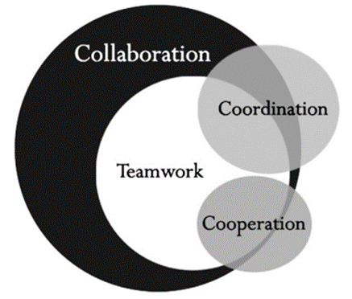
Source: Bedwell et al. (2012)

2.2 Individual versus collaborative (group) decision making
There is a wide variety of experimental research on the systematic differences between individual and collaborative decisions (Ambrus et al., 2009; Charness and Sutter, 2012) and the benefits of collaborative decision making in disparate applications and disciplines such as supply chain networks (Long, 2016a; 2016b), auditing (Baldauf and Steckel, 2012; Zerni et al., 2012), air traffic management and control (Ball et al., 2000), and defence (van Bemmel and Eikelboom, 2008) among others. A section of the literature has, at the same time, investigated whether groups are superior to individuals in terms of making decisions especially in complex situations. Although the debate on whether groups perform better than individuals in decision making tasks is ongoing, findings from the existing body of research have been mixed. While some studies have shown that groups generally outperform individuals in certain tasks (Casari, et al., 2011; Kugler, et al, 2012; Shaw, 1932), others have reported no significant difference or even worse performance by groups in some cases (e.g. Davis, 1992; Kerr, et al., 1996). This is however dependent on the context of the decision (Miner, 1984) as well as individual and procedural differences (Hill, 1982). Thus, it will be wrong to simply conclude that groups are consistently superior to individuals in making decisions.

2.3 Benefits of collaboration
Research in different domains have identified several benefits that decision makers could gain when they make decisions collaboratively. Shaw (1932) reported through experiments that collaborative groups are more likely to correctly solve complex problems than individuals. The author attributed this to the ability of group members to check errors in the group and reject erroneous suggestions. In order words, through deliberations, groups have better chances of identifying and correcting the errors of fellow group members (Kugler, et al, 2012). Additionally, in situations where the actual stage at which the first error was made can be ascertained, Shaw (1932) showed that collaborative groups commit errors much later than average individuals do. Other authors argue that improvement in collaborative, over individual decisions are subject to certain conditions. Callaway, et al. (1985) and Bang and Frith (2017) for instance, maintain that the composition of group members can influence the quality of decisions reached by a group. In particular, the presence of highly dominant members (i.e., people that can persuade and influence others to align with their thoughts) in a group can lead groups to make decisions that are of higher quality (Callaway et al., 1985). This is probably because dominant people have the ability to provide support in the forms of leadership and guidance to other members of the group in making decisions (Edwards, 1954). Such support, which is usually found in cohesive groups, has the advantage of facilitating agreement among group members, but also possesses the drawback of suppressing inquiries that may be critical to the decision (Callaway, et al., 1985).
Furthermore, one of the axioms of collaboration is that it avails participants with a larger pool of information through sharing unique information, which they might have held individually (Johnson and Johnson, 2017). In other words, collaboration can lead to an increase in the quantity and quality of information that is available to decision makers (Perry and Moffat, 2004). Thus, Robbins et al. (2009) maintain that collaborative groups can generate information and knowledge that are more complete than those generated by individuals. However, Xiao et al. (2016) stressed that an improvement in decision making occurs only when the information is equally distributed among the participants. Although not surprising, valuation researchers and professionals have also acknowledged the relevance of information in making good valuation decisions (see for instance Peto, 1997). It follows therefore, that collaboration could provide opportunity for valuers to share information, which may influence the quality of the decisions they make.
Because decision makers have limited capacity to process information (Newell and Simon, 1972), access to more information alone may not lead to better decision if there is no commensurate increase in processing capacity, and it may even result in cognitive overload (Schwartz,2004). Thus, another advantage of collaboration in this regard is that it has the potential to increase decision makers’ capacity to accurately process information when handling complex problems (Hocevar et al., 2004). This is because groups have been found to possess larger cognitive capacities when compared to individuals (Sasaki and Pratt, 2012). In addition to overcoming individual cognitive limitation, making decision in group has also been acknowledged to be a useful approach in addressing the problems of uncertainties and biases that are inherent in complex decision making processes. In particular, groups outperform individuals when making decisions in environments that are surrounded by uncertainties (Bang and Frith, 2017; Kugler et al., 2012).
In terms of biases, studies have shown that both individuals and groups are susceptible to different forms of biases, albeit at different degrees. Kerr, et al. (1996) concluded that there are certain conditions under which individuals could be more or less biased than groups. However, while Kahneman (2003) argued that individuals may not be able to debias themselves, Bang and Frith (2017) highlight the potential of group decision making to overcome biases. They contend that individuals are usually unconscious of their biases, but that such biases can easily be detected by others and can therefore be the subject of discussion if people engage in collaborative decisions. Moreover, Kugler et al. (2012) note that groups exhibit significantly lower biases both in the case of hindsight and overconfidence biases. Still on bias, de Wilde et al. (2018) reported that like individuals, groups are also prone to anchoring bias but suggested that this can be avoided by ensuring process accountability or providing competitive incentive, which Larrick (2004) has described as motivational strategies.
Additionally, when people work collaboratively as a group, they have better abilities to solve problems correctly, produce more accurate forecasts and accurately recall information (Tindale and Kluwe, 2015). Because collaboration and group work bring about diversity and increase in availability of resources to team members, they are able to be more creative in their problem solving and decision making (Cook et al., 2001). Similarly, Robbins et al. (2009) argue that by pooling the resources of the several individuals involved in decision making, groups are not only able to bring more input, but also bring creativity and diversity of views into the decision making process than will do individuals, thereby providing an opportunity for more alternatives to be considered before a final decision is reached. Thus, there are several reasons to believe that more than individuals, groups conform to the assumption of rationality when making decisions (Kulger, et al., 2012).

2.4 Challenges of collaboration
As indicated earlier, it should be noted that although they often do, there is no absolute guarantee that groups will always make better decisions than individuals (Tindale and Kluwe, 2015). Thus, there are potential problems associated with this approach of decision making. For instance, it is argued that collaborative decisions may consume more time and have the risk of conformity pressure and dominance (Robbins et al., 2009). There also exist problems associated with the cost of using groups and how to determine the yardstick for evaluating group performance (Chariri, 1999). Reagan-Cirincione (1994) further highlighted problems that are associated with both the interaction processes (interpersonal and interactional problems faced by groups) as well as the cognitive processing of groups (as a result of task complexities). Other potential problems of collaboration are groupthink, a situation in which groups fail to critically examine opinions that are unusual, minority or unpopular as a result of group pressures, and groupshift, a situation in which group members tend to exaggerate their initial opinion (Robbins et al., 2009). These problems are suggestive that collaboration might not always lead to better decisions.
These shortcomings notwithstanding, the potential benefits of collaboration cannot be simply ignored especially given the empirical evidence from different domains suggesting the superiority of collaborative (group) decisions over those made by individuals in isolation in several decision situations. Bang and Frith (2017) have suggested different ways to avoid the common traps associated with collaboration. These include weighing opinions, anonymous interaction (through feedback, for instance), uncovering information, setting of explicit rules and good leadership. Reagan-Cirincione (1994) further notes that the problems of interaction processes and cognitive processing they identified can be overcome through the use of external decision models and technology among others. Improving decisions using collaborative approach will, to a large extent, depend on the diversity of experiences and trainings of the group members, and the extent to which the group’s discussion is guided towards exploiting such diversity (Larrick, 2004). It thus follows that, if properly used, collaboration can be a veritable tool that can enhance decision making.

3. Collaboration in the Valuation Decision Making Process

3.1 Empirical Studies on Collaboration Within the Valuation Process
In this study, collaboration is conceptualised in line with the perspective of Roschelle and Teasley (1995) provided earlier. From this perspective, we view collaboration as a series of social interactions that take place between a valuer that is responsible for carrying out a valuation assignment and other parties (either valuers or non-valuers) that may or may not be legally responsible for the valuation, but in some ways, make inputs into the valuation decision making process. Such inputs could be either through discussing aspects of the valuation (Havard, 2005) or even by merely providing evidence to support the valuation (Amidu and Boyd, 2018). Although literature on collaboration in the valuation decision making process is noticeably sparce, emerging evidence within the behavioural valuation literature point to the occurrence of different forms of interactions in the valuation process. Existing research suggests that such interactions (collaboration) take place both within and outside of the responsible valuer’s valuation firm for a variety of reasons.
According to Havard (2005), owing to its complexities, a typical commercial valuation assignment will require the valuers to consult and interact with many other people both within and outside their valuation firm, with majority of these consultations taking place in-house (i.e., within firm). It is noted that within firms, valuers often interact with and consult their partners, other valuers, letting agents and investment agents. On the other hand, interactions outside of the valuers’ firms usually involve, to a large extent, the clients and then valuers from other firms. The status of the parties involved as well as their levels of involvement vary throughout the valuation process. Havard found that senior valuers tend to be remotely involved from most part of the valuation process, typically engaging with the clients and performing oversight function of ensuring quality of the valuations produced, while the junior valuers are in most cases involved in carrying out the tasks of inspection and measurements as well as the collection of comparable evidence. This scenario, according to the author, depicts the happenings in large and medium sized valuation firms. However, in most small sized firms, senior valuers have been found to be more involved in all stages of the valuation process and engage in lower levels of consultations when compared with larger firms (Havard, 2005).
Furthermore, Klamer et al. (2018) reported that collaborative practices often occur within firms at the process stage of the valuation, particularly in the stages of comparable sales analysis, market sentiment analysis and modelling considerations. In all these instances, the authors note that large property firms often utilize transaction database and other information that are “fuelled and verified by research and brokerage departments” of the firms. Unfortunately, SME and self-employed valuers do not have these in-house departments from which to source for this useful information. Rather, they were found to use alternative sources of information such as those available commercially, which may sometimes be unreliable and may require further verification (Klamer et al., 2018, p. 217).
The practice of contacting external sources has also been reported in another recent study by Amidu and Boyd (2018). In this study, the authors reported that valuers do engage in “collaborative process with other colleagues, who possess different, but complementary, knowledge and skills required for judgement and decision making in valuation problem solving” (Amidu and Boyd, 2018, p. 374). Specifically, valuers stated that they collaborate to widen their scope of data search (information acquisition) and determine proper valuation technique (methodology) to adopt when solving valuation problems. These align with the benefits of collaboration in the aspect of information acquisition and processing that were highlighted earlier (Hocevar et al., 2004; Robbins et al. 2009). By asking questions from those that are perceived as being more knowledgeable and experienced, valuers are able to increase their knowledge base and consequently improve their valuation problem solving (Amidu and Boyd, 2018). Following on these findings, the authors recommended that an investigation be carried out on whether joint (i.e., collaborative) valuation contributes to valuation quality.
Other studies devoted to understanding client influence in valuation (for example Baum et al., 2000; Kinnard et al. 1997; Lee et al., 2020; Levy and Schuck, 1999; 2005) have also shown that series of interactions in the form of agent principal relationship take place between valuers and clients throughout the valuation process. These interactions constitute an important component of the valuation decision making process because valuers often depend on clients for substantial amount of information relating to the subject property and sometimes even the property market. Although these studies revealed that these interactions are potential causes of bias (Diaz, 2002), they also suggest that such interactions could sometimes be useful in ensuring market credibility and accuracy of valuations, which could be achieved through quality control roles exercised by clients in the valuation process (Levy and Schuck, 2005).

3.2 Collaboration as Prescribed by Valuation Professional Standards
From professional standards perspective, the International Valuation Standards Council (IVSC) and the Royal Institution of Chartered Surveyors (RICS) which are among the major professional bodies that set and maintain standards that guide professional valuation practice globally have also recognized that some form of collaboration can take place in valuation practice. Specifically, the 2022 International Valuation Standards (IVS) states that “Valuations must be prepared by an individual, group of individuals or individual within an entity, regardless of whether employed (internal) or engaged (contracted/external), possessing the necessary qualifications, ability and experience to execute a valuation in an objective, unbiased, ethical and competent manner and having the appropriate technical skills, experience and knowledge of the subject of the valuation, the market(s) in which it trades and the purpose of the valuation.” [bold added] (IVSC, 2022, p. 11). Similarly, the 2022 edition of the RICS Valuation – Global Standards (i.e., the Red Book Global Standards), which complies with the IVS also recognises that other members or valuers could make input in a valuation even though the outcome of the valuation remains the responsibility of the named valuer (RICS, 2022). More explicitly, paragraph 2.5 of the Red Book Global Standards states that when undertaking valuations, “personal knowledge and skill requirements may be met in aggregate by more than one member within a firm” [bold added] (RICS, 2022, p. 24). Yet, empirical research has not investigated how such aggregation of knowledge and skills occurs in practice.
While it is acknowledged here that a significant amount of research on valuer’s decision making behaviour has been conducted, it is noteworthy that to date, with the exception of the few studies mentioned above, the primary focus of the existing body of research has been on understanding individual valuer behaviour. However, the decision making literature from other domains (reviewed in the previous section) points to the existence of systematic differences between individual and collaborative decisions (Ambrus et al, 2009; Charness and Sutter, 2012). Although the existing valuation studies reviewed in this paper indicate the prevalence of collaborative practices in the valuation decision making process, a major limitation of such studies is that they neither provided actual account (i.e., a description) of how such collaborations occurs, nor have they examined its impact on valuation decisions. Findings from these studies are somewhat limited to answering the question of “who” is consulted but did not adequately address “how” such consultations take place and its impact on the quality of valuation decisions, thereby providing opportunity for an in-depth exploration to be carried out in this direction. The next section proposes a conceptual framework to guide such an exploration.

4. Conceptual framework for analysing collaboration In the Valuation decision making process
In order to achieve the goal of collaboration, that is, to enhance the provision of services, there is need for engagement among various participants at different levels (Whittington, 2003). Hence, several models of collaboration have been developed in the literature in fields like education, organisational management, and professional services such as healthcare (see, for example, Bedford et al., 2008; Keyton et al, 2008; Long, 2016a, b; Whittington, 2003). Using a healthcare setting, Whittington (2003) developed a model that illustrates the various dimensions of collaboration which he labelled as “spheres of interaction”. The four spheres, according to Whittington (2003) are interpersonal, interprofessional, inter-disciplinary and inter-organisational interactions. Based on the valuation literature reviewed in the previous section, we chose Whittington’s model as an appropriate framework for analysing collaboration in the valuation decision making process. An adapted version of the model is presented in Figure 3.
Figure 3: Conceptual framework for analysing collaboration in the valuation process.
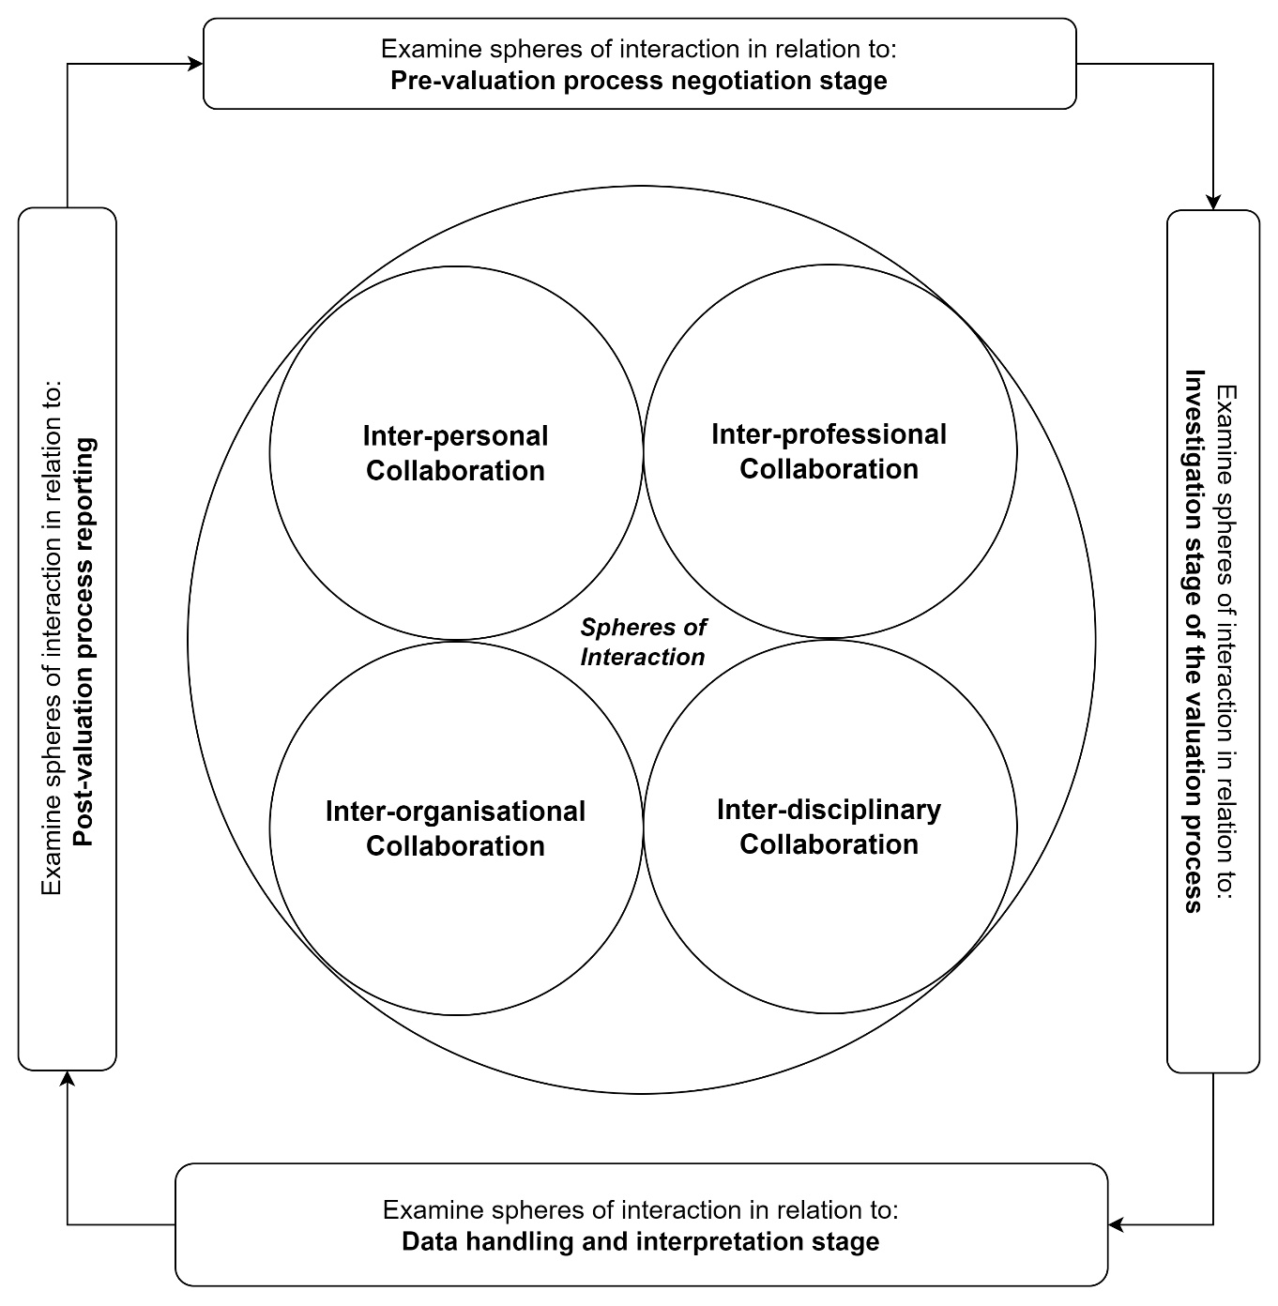
In this proposed framework, the analysis of inter-personal collaboration will focus on the interaction between valuers carrying out a valuation together (i.e., valuers working within the same team). Interprofessional collaboration will dwell on exploring the interactions that occur between valuers and other allied professionals in the valuation process. Inter-disciplinary collaboration will examine interactions between different teams working within the same valuation firm. While valuers are generally viewed as belonging to the same discipline, this sphere of interaction might be useful when analysing large valuation firms which are likely to have several teams with each team specialising in a particular niche (i.e., discipline). Whittington (2003) also described this sphere as “team” in his initial model, which further reaffirms that the focus of this sphere is on interactions between different teams. We note, however, that this type of collaboration might not be prevalent in smaller firms as they are not likely to have multiple teams working separately. Finally, the inter-organisational sphere can be useful in analysing interactions that occur between different valuation firms when carrying out a valuation assignment.

5. Conclusion and future research direction
The importance of accurate valuations to businesses and the economy at large cannot be overemphasised. The behavioural valuation literature has shown that valuers are prone to different types of biases, which can undermine the quality of their valuation decisions. Efforts towards addressing valuation bias and improving the overall quality of valuation decision making must be rooted in an in-depth understanding of the decision making process. However, the bulk of research in this area has focused on understanding individual valuer behaviour whereas the behaviour of valuers in a collaborative context has not been properly examined. Given the central role of collaboration in the valuation process as highlighted in this paper, and its potential as an approach to improving the quality of valuation decision making, we argue that more research effort needs to be directed towards understanding valuers’ collaborative behaviour as a foundation for providing prescriptive advice on how such behaviour can be improved to achieve higher quality valuations. Previous studies have argued that interaction (i.e., collaboration) within the valuation process should be critically examined and modelled (Havard, 2005), while also calling for investigation into how this contributes to the quality of valuations (Amidu and Boyd, 2018).
Against the foregoing, the present research has further identified opportunity to explore the nature of collaborative practices as they currently occur in the valuation process. This might help us understand how such interactions affect valuers’ decisions and provide theoretical bases upon which valuers could be advised on how to improve their decisions, which is the primary aim of valuation decision making research. Addressing this gap in knowledge is the subject of forthcoming studies by the authors, which seek to, among others, answer some of the following important questions: how do valuers conceptualise collaboration in practice? what are the dynamics of collaboration in the property valuation decision making process? what are the motivations for collaboration? when is collaboration productive? when is it not appropriate? how does collaboration contribute to the quality of valuation decisions? These and many other related research questions on collaboration in the valuation decision making process can be examined through the conceptual framework proposed in Figure 3. We believe that empirical evidence from such studies can provide insights that may be used to enhance collaborative practices in the valuation process.

References
Ambrus, A., Greiner, B. and Pathak, P., 2009. Group versus individual decision-making: Is there a shift. Institute for Advanced Study, School of Social Science Economics Working Paper, 91.
Amidu, A.R. and Boyd, D., 2018. Expert problem solving practice in commercial property valuation: an exploratory study. Journal of Property Investment and Finance, 36(4), pp.366-382.
Amidu, A.R., 2011. Research in valuation decision making processes: Educational insights and perspectives. Journal of Real Estate Practice and Education, 14(1), pp.19-34.
Amidu, A.R., Boyd, D. and Agboola, A.O., 2019. The role of knowledge in valuation practice: expert valuers’ perceptions. Journal of Property Investment and Finance, 37(6), pp.524-540.
Ashton, R.H., 1982. Human information processing research in auditing A review and synthesis.
Baldauf, J. and Steckel, R., 2012. Joint audit and accuracy of the auditor's report: an empirical study. International Journal of Economic Sciences and Applied Research, 5(2), pp.7-42.
Ball, M.O., Hoffman, R.L., Knorr, D., Wetherly, J. and Wambsganss, M., 2000. Assessing the benefits of collaborative decision making in air traffic management. In Proc. 3rd USA/Europe Air Traffic Management R&D Seminar, Napoli, Italy.
Bang, D. and Frith, C.D., 2017. Making better decisions in groups. Royal Society open science, 4(8), p.170193.
Baum, A., Crosby, N., Gallimore, P., McAllister, P. and Gray, A., 2000. The influence of valuers and valuations on the workings of the commercial property investment market. In Royal Institution of Chartered Surveyors/Investment Property Forum, London.
Bedford, D., Jackson, C.R. and Wilson, E., 2008. New partnerships for learning: Teachers’ perspectives on their developing professional relationships with teaching assistants in England. Journal of In‐service Education, 34(1), pp.7-25.
Bedwell, W.L., Wildman, J.L., DiazGranados, D., Salazar, M., Kramer, W.S. and Salas, E., 2012. Collaboration at work: An integrative multilevel conceptualization. Human resource management review, 22(2), pp.128-145.
Bedwell, W.L., Wildman, J.L., DiazGranados, D., Salazar, M., Kramer, W.S. and Salas, E., 2012. Collaboration at work: An integrative multilevel conceptualization. Human resource management review, 22(2), pp.128-145.
Callaway, M.R., Marriott, R.G. and Esser, J.K., 1985. Effects of dominance on group decision making: toward a stress-reduction explanation of groupthink. Journal of personality and social psychology, 49(4), p.949.
Casari, M., Zhang, J. and Jackson, C., 2011. When do groups perform better than individuals? A company takeover experiment.
Chariri, A., 1999. Cognitive limitations and decision making. Jurnal Bisnis Strategi, 3(2), pp.21-28.
Charness, G. and Sutter, M., 2012. Groups make better self-interested decisions. Journal of economic perspectives, 26(3), pp.157-176.
Cook, G., Gerrish, K. and Clarke, C., 2001. Decision-making in teams: issues arising from two UK evaluations. Journal of interprofessional care, 15(2), pp.141-151.
Davis, J.H., 1992. Some compelling intuitions about group consensus decisions, theoretical and empirical research, and interpersonal aggregation phenomena: Selected examples 1950–1990. Organizational Behavior and Human Decision Processes, 52(1), pp.3-38.
de Wilde, T.R., Ten Velden, F.S. and De Dreu, C.K., 2018. The anchoring-bias in groups. Journal of Experimental Social Psychology, 76, pp.116-126.
Diaz, J., 1999. The first decade of behavioral research in the discipline of property. Journal of Property Investment and Finance, 17(4), pp.326-332.
Edwards, W., 1954. The theory of decision making. Psychological bulletin, 51(4), p.380.
Gray, B. (1989). Collaborating: Finding common ground for multiparty problems.
Havard, T., 2005. The Commercial Valuation Process: Task Order, Personnel and Consultation. Pacific Rim Property Research Journal, 11(1), pp.3-23.
Hill, G.W., 1982. Group versus individual performance: Are N+ 1 heads better than one?. Psychological bulletin, 91(3), p.517.
Hocevar, S.P., Jansen, E. and Thomas, G.F., 2004. Building collaborative capacity for homeland security. Monterey, California. Naval Postgraduate School.
IVSC (2022), International Valuations Standards 2022, International Valuation Standards Council, London.
Jassawalla, A.R. and Sashittal, H.C., 1999. Building collaborative cross-functional new product teams. Academy of Management Perspectives, 13(3), pp.50-63.
Johnson, D.W. and Johnson, F.P., 1991. Joining together: Group theory and group skills. New York : Pearson
Johnson, D.W. and Johnson, F.P., 2017. Joining together: Group theory and group skills (12" Ed.).
Kahneman, D., 2003. A perspective on judgment and choice: mapping bounded rationality. American psychologist, 58(9), p.697.
Kerr, N.L., MacCoun, R.J. and Kramer, G.P., 1996. Bias in judgment: Comparing individuals and groups. Psychological review, 103(4), p.687.
Keyton, J., Ford, D.J. and Smith, F.L., 2008. A mesolevel communicative model of collaboration. Communication theory, 18(3), pp.376-406.
Kinnard, W.N., Lenk, M.M. and Worzala, E.M., 1997. Client pressure in the commercial appraisal industry: how prevalent is it?. Journal of Property Valuation and Investment, 15(3), pp.233-244.
Klamer, P., Bakker, C. and Gruis, V., 2018. Complexity in valuation practice: an inquiry into valuers’ perceptions of task complexity in the Dutch real estate market. Journal of Property Research, 35(3), pp.209-233.
Kugler, T., Kausel, E.E. and Kocher, M.G., 2012. Are groups more rational than individuals? A review of interactive decision making in groups. Wiley interdisciplinary reviews: Cognitive science, 3(4), pp.471-482.
Larrick, R.P., 2004. Debiasing. Blackwell handbook of judgment and decision making, pp.316-338.
Lee, M.H., Peng, C.W. and Liao, H.F., 2020. An Analysis of Objectivity in the Real Estate Appraisal Process. International Real Estate Review, 23(4).
Levy, D. and Schuck, E., 1999. The influence of clients on valuations. Journal of Property Investment and Finance, 17(4), pp.380-400.
Levy, D. and Schuck, E., 2005. The influence of clients on valuations: the clients' perspective. Journal of Property Investment and Finance, 23(2), pp.182-201.
Long, Q., 2016a. A flow-based three-dimensional collaborative decision-making model for supply-chain networks. Knowledge-Based Systems, 97, pp.101-110.
Long, Q., 2016b. A multi-methodological collaborative simulation for inter-organizational supply chain networks. Knowledge-Based Systems, 96, pp.84-95.
Mattessich, P.W. and Monsey, B.R., 1992. Collaboration: what makes it work. A review of research literature on factors influencing successful collaboration. Amherst H. Wilder Foundation, 919 Lafond, St. Paul, MN 55104.
Miner Jr, F.C., 1984. Group versus individual decision making: An investigation of performance measures, decision strategies, and process losses/gains. Organizational Behavior and Human Performance, 33(1), pp.112-124.
Newell, A. and Simon, H.A., 1972. Human problem solving (Vol. 104, No. 9). Englewood Cliffs, NJ: Prentice-hall.
Perry, W.L. and Moffat, J., 2004. Information sharing among military headquarters: The effects on decision making. Rand.
Peto, R., 1997. Market information management for better valuations: Part II‐data availability and application. Journal of Property Valuation and Investment, 15(5), pp.411-422.
Reagan-Cirincione, P., 1994. Improving the accuracy of group judgment: A process intervention combining group facilitation, social judgment analysis, and information technology. Organizational Behavior and Human Decision Processes, 58(2), pp.246-270.
RICS. (2022). RICS Valuation – Global Standards. London: Royal Institution of Chartered Surveyors.
Robbins, S.P., Judge, T. A., Odendaal, A. and Roodt, G., 2009. Organisational behaviour in Southern Africa. Pearson South Africa.
Roschelle, J. and Teasley, S.D., 1995. The construction of shared knowledge in collaborative problem solving. In Computer supported collaborative learning (pp. 69-97). Springer Berlin Heidelberg.
Sasaki, T. and Pratt, S.C., 2012. Groups have a larger cognitive capacity than individuals. Current Biology, 22(19), pp.R827-R829.
Schwartz, B., 2004. The paradox of choice: Why more is less. New York.
Selvaraj, N., 2016. Collaborative decision making in complex work settings: a process of managing inter dependencies (Doctoral dissertation, Middlesex University).
Shaw, M.E., 1932. A comparison of individuals and small groups in the rational solution of complex problems. The American Journal of Psychology, 44(3), pp.491-504.
Tindale, R.S. and Kluwe, K., 2015. Decision making in groups and organizations. The Wiley Blackwell handbook of judgment and decision making, 2, pp.849-874.
Trotman, K. T. (1998). Audit judgment research—Issues addressed, research methods and future directions. Accounting and Finance, 38(2), 115-156.
Trotman, K.T., 1998. Audit judgment research—Issues addressed, research methods and future directions. Accounting and Finance, 38(2), pp.115-156.
van Bemmel, I.E. and Eikelboom, A.R., 2014. Collaborative Decision Making Process for Complex Defense, Security and Stability Challenges.
Vlek, C., 1984. What constitutes ‘a good decision’?: a panel discussion among Ward Edwards, István Kiss, Giandomenico Majone and Masanao Toda. Acta psychologica, 56(1-3), pp.5-27.
Wang, S. and Noe, R.A., 2010. Knowledge sharing: A review and directions for future research. Human resource management review, 20(2), pp.115-131.
Wang, S. and Noe, R.A., 2010. Knowledge sharing: A review and directions for future research. Human resource management review, 20(2), pp.115-131.
Whittington, C., 2003. A model of collaboration. Collaboration in social work practice, pp.39-62.
Wilkinson, S.A.R.A., Antoniades, H. and Halvitigala, D., 2017. The future of the valuation profession.
Xiao, Y., Zhang, H. and Basadur, T.M., 2016. Does information sharing always improve team decision making? An examination of the hidden profile condition in new product development. Journal of Business Research, 69(2), pp.587-595.
Zerni, M., Haapamäki, E., Järvinen, T. and Niemi, L., 2012. Do joint audits improve audit quality? Evidence from voluntary joint audits. European Accounting Review, 21(4), pp.731-765.

